Production Platforms test

# Exercise 1 - SQL

Resolution time = 45 min

Use the sample database AdventureWorks to create the following queries.

**1). Show the order quantity (OrderQty), the Name of the product (Name) and the price (ListPrice) of the order made by CustomerID 29531**

**2). How many products in ProductCategory ‘Mountain Bikes’ have been sold to an address in ‘Toronto’?**

**3). Show the number of orders by range (in $), and the total sum:**

RANGE Num Orders Total Value

0- 99

100- 999

1000-9999

10000-

Please enclose an .sql text file with the 3 queries.

(*) You can use the following link to download a free version of SQL Server (SQL Server ExpressGet SQL Server Express) and the sample database AdventureWorks from here:

https://www.microsoft.com/es-es/sql-server/sql-server-downloads

<https://docs.microsoft.com/es-es/dotnet/framework/data/adonet/sql/linq/downloading-sample-databases#get_ssms>

AdventureWorks diagram:

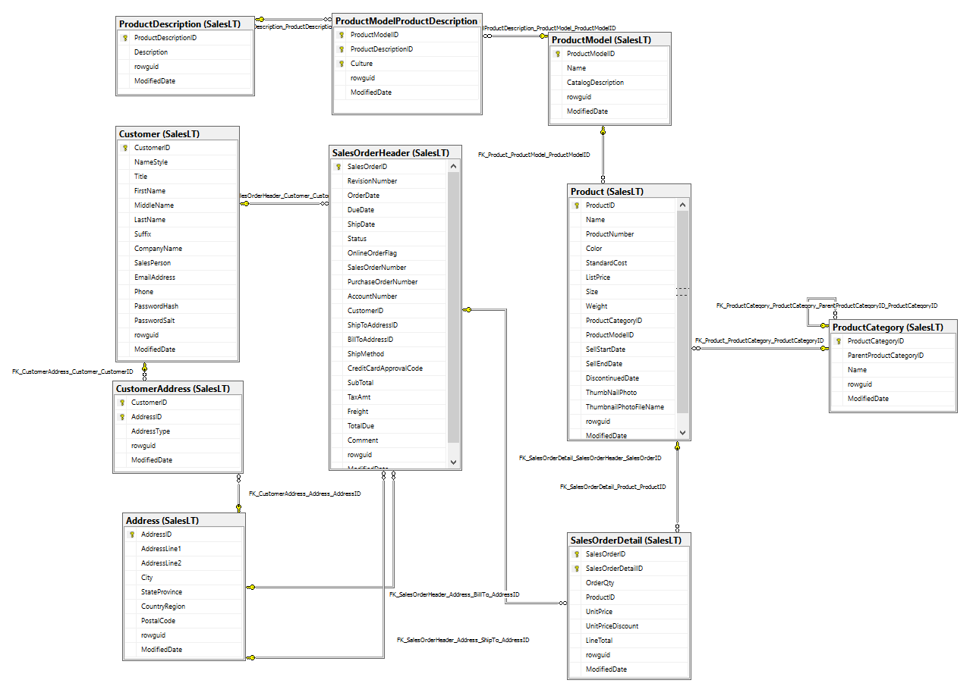

# Exercise 2 – C#

Resolution time = 60 min

Create a class "Point3D", to represent a point in 3-D space, with coordinates X, Y and Z. It must contain the following methods, as the necessary getters & setters:

* MoveTo, which will change the coordinates in which the point is.
* DistanceTo(Point3D p2), to calculate the distance to another point.
* ToString, which will return a string similar to "(2,-7,0)"

The test program must read the data of 5 points included in the text input file Input3DPoints.txt, get data for them, and calculate (and display) the distance from the first point to the remaining four ones.

Please, send the visual studio project of the application, zipped, along with your comments in the code.

(*) Visual Studio Code edition it’s ok.

# Exercise 3 – English

Resolution time = 15 min

Write an informal letter (100 words) trying to convince a colleague from abroad to come to study or work to Barcelona or Sant Cugat.